Analysis of Extended Realities

# Extended Realities and Their Uses

## Uses in PC Games

Currently, VR is the best tool when it comes to immersing your players. Whether it be a sci-fi dystopia like Half Life: Alyx, or a fantasy adventure like Skyrim, players can feel like they are truly inhabiting the fictional world.

VR’s benefits to storytelling can be seen in Half Life: Alyx. By using VR and placing the player in the shoes of the protagonist, the story is more impactful and personal. This point is true for both planned story beats, and more improvised, player driven stories.

*“A midgame threat forces you to make as little noise as possible … When two cans fell and I caught them just before they hit the ground, I purposefully whispered “yes!” rather than saying it out loud.”*

VR can also enhance experiences that you would see in a traditional game, such as sword fighting as seen in Blade & Sorcery. Instead of set animations and moves, the player must physically strike their opponent and block attacks in combat. This achieves a high sense of realism, and something unachievable in a traditional game.

Lastly, VR can be used to make an environment more alive and interactive than a normal game. In a traditional game, most things are immovable which can take the player out of their experience depending on the gameplay. Whereas in games like Job Simulator, you can move and interact with most of the objects around you, which grounds the player and makes them feel like they are in an actual, physical environment.

## Uses in Workplace Training

One of the increasingly popular uses for VR is in training. Workplaces of varying industry can see benefits relating to cost, effectiveness, risk, and time when employing VR in their training process.

Companies like BP and ExxonMobil use VR to negate many of the risks involved learning dangerous jobs such as working on oil refineries or gas tankers. Trainees can get practical experience before they get on the real site, and any mistake that could have proven fatal can now just be a learning experience.

The time and cost of training employees can be reduced through VR training because there is less of a need for expensive equipment and supervisors. Training with VR is closer to the real job, and it’s more interactive so the employee can gain experience more quickly when going through tailored scenarios.

# UI Design in Virtual Reality Games

UI and HUD work differently in VR than traditional games because we don’t normally experience anything external that’s tied to our vision. Traditional games can get away with non-diegetic UI, but in VR it becomes disorienting and jarring.

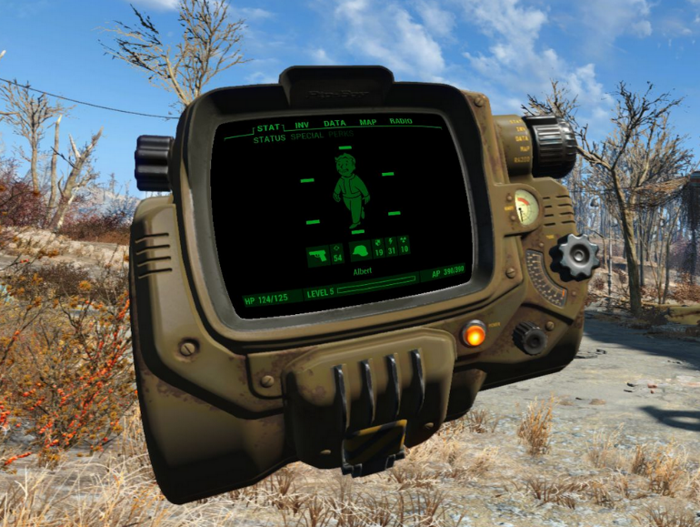This is why most games go with HUD that lies within the environment or on the player’s hand which are always accessible.

Fallout 4 VR Menu

Star Wars: Squadrons VR Ship UI

Half Life: Alyx Health HUD

# Physiological Constraints of Extended Realities

In extended realities there are many physiological constraints that developers have to take into consideration. A major constraint is motion sickness, and that women experience it more in VR.

This is due to the average IPD (Interpupillary Distance – distance between pupils) between men and women being different. The Sony PlayStation VR headset is one of the only headsets that implements a wide IPD range which accommodates both men and women’s average IPD.

“… when females could properly fit their IPD to the VR headset, they experienced cybersickness in a manner similar to males …”

# Haptic Feedback in Extended Realities

Haptic feedback is the simulation of touch that you would actually experience in real life, which is usually achieved through varied vibrations. VR uses this to ground the player in the game and does this in multiple ways, such as haptic controllers, vests, and headsets.

There are different kinds of haptic controllers, but they are usual purpose is to simulate holding different objects and give the sense of touching the world. Using the vest and headset, the game can simulate the player getting attacked which could increase immersion.

# Sources

VR in PC Games:

<https://www.washingtonpost.com/video-games/2020/03/31/half-life-alyx-vr-problems-future>

VR in Workplace Training:

<https://www.viar360.com/companies-using-virtual-reality-employee-training/?amp>

<https://immersive.video/vr-ar-articles-news/virtual-reality-training-induction/>

Physiological Constraints of Extended Realities:

<https://www.frontiersin.org/articles/10.3389/frobt.2020.00004/full>

Haptic Feedback:

<https://www.ultraleap.com/company/news/blog/what-is-haptic-feedback/>